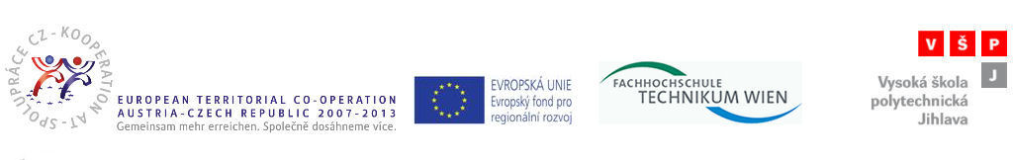

Meeting with Students practical training practices participants report
Date: 2. 12. 2010
At 2. 12. 2010 was Meeting with students practical training practices participants (1. 7. 2010 – 7. 10. 2010) for subject PS and AI studens.
The meeting was for students of 4. term, subject Computer systems and applied informatics.
Students practical training practices participants informed their schoolmates of their practices, problems and advantages these practices and all practices organization side.
During these short meeting was showed interesting photos from practices and it was showed interesting internet references about practice.
Next all was informed of PaedDr. Frantisek Smrcka, Ph.D. about practices registration possibilities, practices duration and - important contact

